Grades 2 and 3 Supply List
2019-2020

Individual Student Supplies (Expected on First Day of School, August 26, 2019)
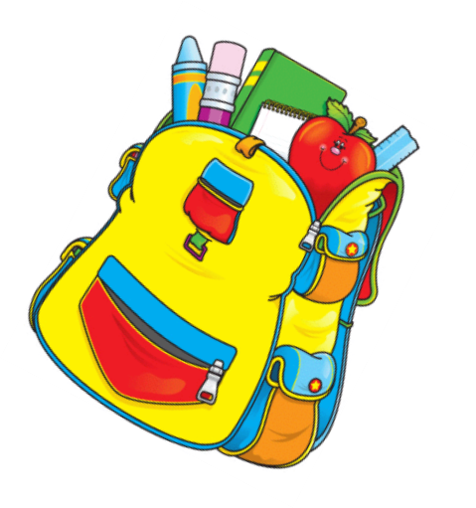
1 Backpack
1 pair Headphones (compatible with iPad)
1 box #2 Pencils sharpened
2 Pink Pearl Erasers
8 Crayola crayons
1 8 count washable markers
1 Purple Pen (for correcting)
2 Glue Sticks
1 Zippered Pencil Case for carrying supplies
2 2 pocket folders
3 Composition Books (WIDE ruled)

*Students will read multiple novels over the course of the school year. Students will be
responsible for purchasing a physical copy or digital ebook for each novel. Teachers will provide a list of all novels and when they need to be purchased at the start of the school year.*

Communal Classroom Supplies
Required from every student
1 package WIDE Ruled Filler Paper
3 reams White Copy Paper
2 packs 3x5 Index Cards
2 boxes Kleenex
1 roll Paper Towels
1 container Disinfectant Wipes

**Please do not purchase personal pencil sharpeners or metal pencil box with a key.**
***Please do not purchase liquid/tape white out, Sharpies, or other permanent markers.***

Thank you for your support and cooperation!

