Grades 4 and 5 Supply List
2019-2020

Individual Student Supplies (Expected on First Day of School, August 26, 2019)
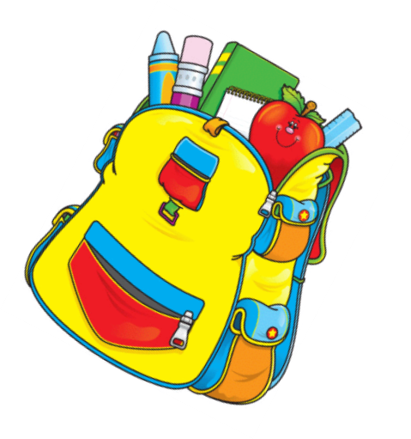
1 Backpack
1 pair Headphones (compatible with iPad)
3 #2 Pencils
2 Pink Pearl Erasers
8 Crayola crayons
1 Purple Pen (for correcting)
2 Glue Sticks
1 Plastic Pencil Box or Zippered Pencil Case
(for carrying supplies listed above)
1 Accordion Folder (6 divisions minimum)
3 Composition Books (college ruled)

*Students will read multiple novels over the course of the school year. Students will be
responsible for purchasing a physical copy or digital ebook for each novel. Teachers will provide a list of all novels and when they need to be purchased at the start of the school year.*

Communal Classroom Supplies
Required from every student

1 package College Ruled Filler Paper
3 reams White Copy Paper
1 box #2 Pencils
2 packs 3x5 Index Cards
1 pack Washable Markers
2 boxes Kleenex
2 rolls Paper Towels
2 containers Disinfectant Wipes

**Please do not purchase personal pencil sharpeners or metal pencil box with a key.**
***Please do not purchase liquid/tape white out, Sharpies, or other permanent markers.***

Thank you for your support and cooperation!

