St. Catherine of Siena School
Kindergarten Supply List 2019-2020
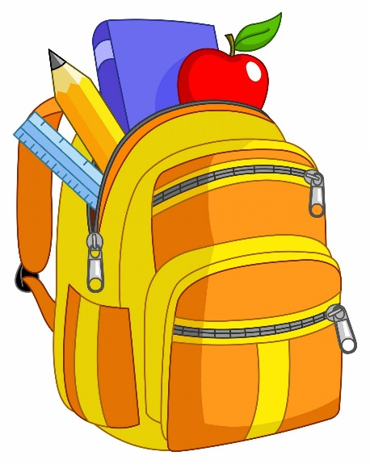
Individual Supplies
Please mark your child’s name on the following:
4 boxes of 24 count Crayola Crayons
1 pencil box
1 backpack (Large enough for folders and sweaters.)
1 pair of small safety scissors
1 folder for homework (any color/design)
Community Supplies (These items do not require a name.)
1 box of 12 count Crayola Color Pencils
1 Crayola Watercolor Paint Set- 8 Colors
6 Elmer’s glue sticks
2 4 oz bottle of Elmer’s Glue
1 pink Pearl Eraser
2 packages of #2 pencils
4 black Expo markers
4 cans of Play-doh
3 reams of white photocopy paper
2 tissue boxes

Boys Only:
2 containers of Clorox Wipes
1 package of white cardstock
2 rolls paper towels

Girls Only:
2 containers of baby wipes
1 package of multi-color cardstock
1 package of manila paper

*Please send a full change of clothes (shirt, bottom, underwear and socks) in case of a
restroom accident. This change of clothes does not need to be school uniform*

