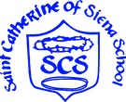
St. Catherine of Siena School
TK School supplies list

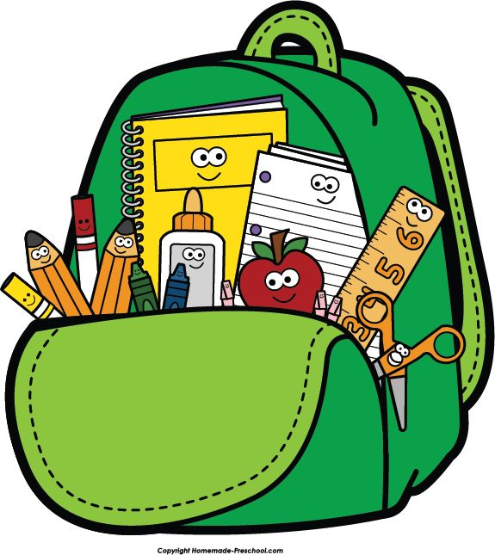

Student’s school supplies
All items need to be marked in markers with your child's name and grade.

1 box crayola crayons (8 counts , large size)
1 box of chubby beginner pencil
5 glue sticks (elmers, lakeshore brand preferred)
1 set of watercolor paints
1 package of thick markers
1 pencil box
1 plastic folder
4 packs play dough ( primary colors)
3 reams copy paper white
3 boxes of kleenex
3 containers of disinfecting wipes
3 packages of baby wipes
1 backpack ( no wheels please)
1 emergency outfit (clean socks, underwear, pants, and shirt) for bathroom accident. (These do not have to be uniform clothes)
1 nap bag ( blanket and cot sheet cover)

